How to build APK from Visual Studio

1. Go to properties under Android Project

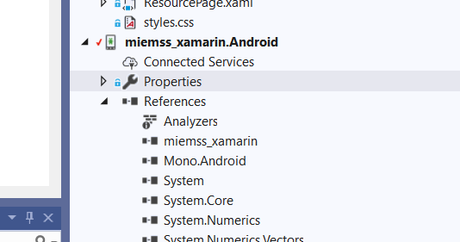

1. Uncheck “Use Shared Runtime and Use Fast Deployment”

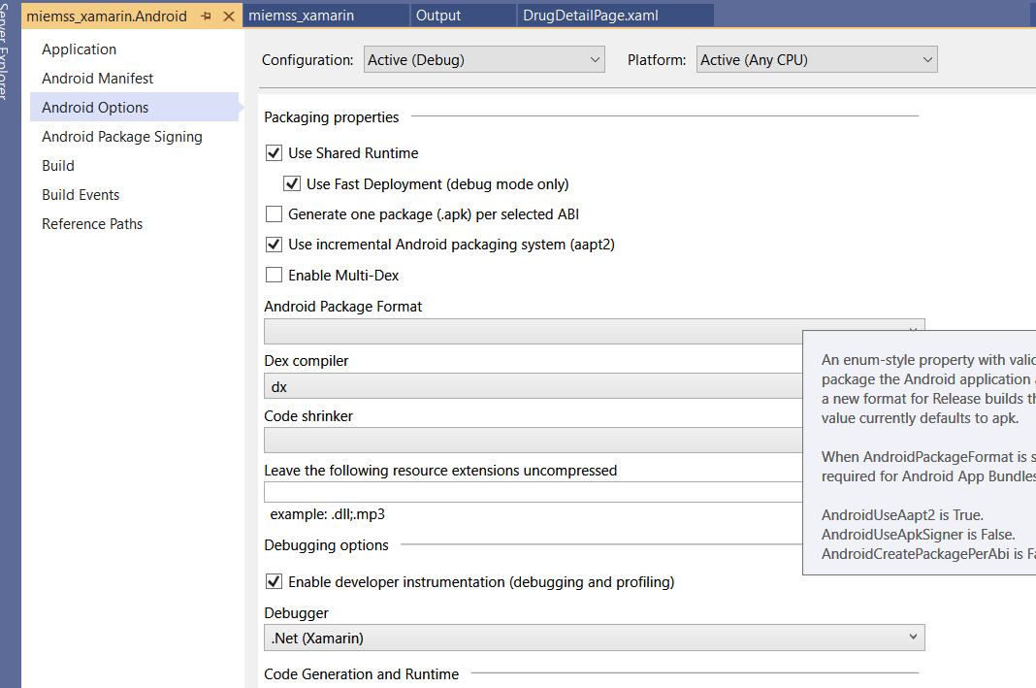

1. Choose APK as Package Format

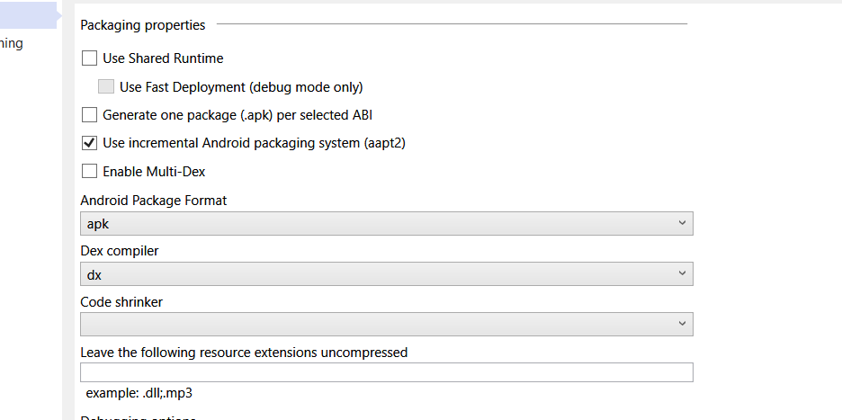

1. Choose SDK Assemblies Only as Linking



1. Start Build and Go to Archive

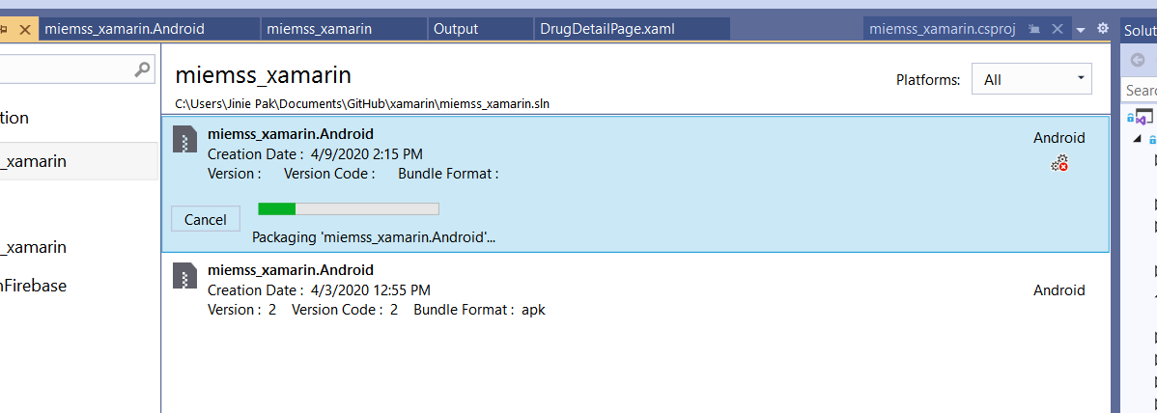

1. Once successfully built, you will see this screen and choose ‘Distribute’.

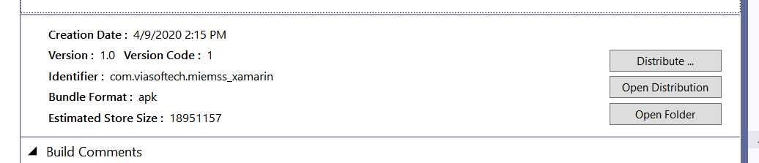

1. Choose Ad-Hoc and create Sign Identity. It will ask you to enter passcode that you just created.

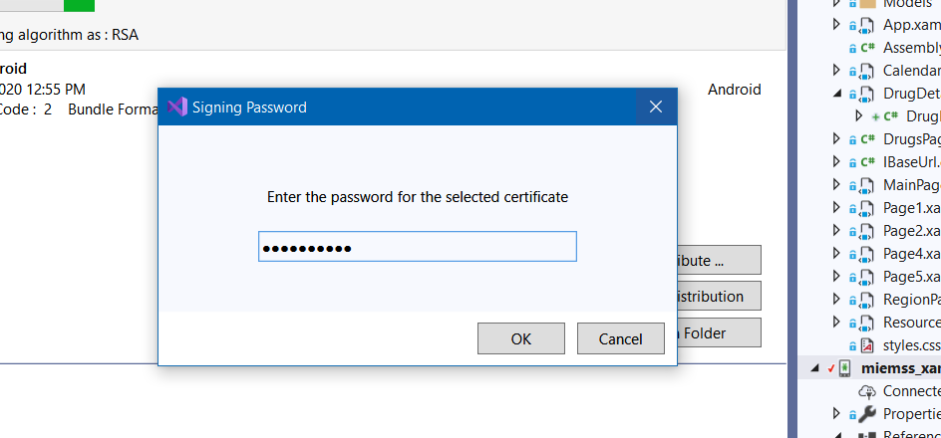

1. Save the file in a directory